HAZARD/CONCERN REPORT
Location:
PART 1 TO BE FILLED OUT BY THE WORKER
Reported to: |  |  | Date Reported:
Description of hazard/concern:
Describe in detail and be specific (e.g., ice on front sidewalks, security procedures not followed after school hours, broken ladder in classroom 292). Use an additional sheet of paper if required.
Corrective action taken:
Describe what has been done already to eliminate this hazard or reduce the associated risk, by whom and date.
Residual risk rating:
See next page for matrix
Solutions/corrective actions recommended:
Describe in detail your ideas on how to eliminate this hazard or reduce associated risk. Use an additional sheet of paper if required.
Part 1 Completed by:
Name, Title and Phone Number (Please Print) |  | Date |  | Signature
PART 2 TO BE FILLED OUT BY THE SUPERVISOR
Corrective Actions Identified
Corrective action/Control to be implemented | Degree of risk | Completion Target Date (YY/MM/DD) |  | Date Completed (YY/MM/DD) | Verified by  (Signature)
Part 2 Completed by:
Name & Title (Please Print) |  | Date |  | Signature

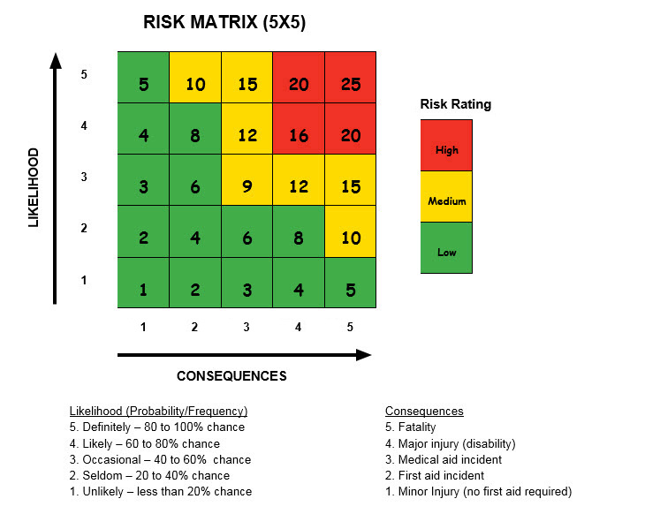

For each hazard, determine the frequency of the hazard. Next consider the potential consequence if something occurs. Using the risk matrix, determine the specific risk value (i.e., high, medium or low) of each hazard. Consider all factors that contribute to the degree of risk for each hazard presented to each group of workers. Consider the following factors to determine likelihood and potential consequences:

- How often is the task performed: multiple times a day, daily, once a week or once a year? The more frequent a task is performed the greater the likelihood or chance there is for something to go wrong.
- If something did go wrong, how severe could the consequences be? Would the incident result in only minor injury or could it result in a fatality?

